**Chapter 1: INTRODUCTION**

* 1. **Android as an Operating System**

Being a mobile operating system, android OS is a modified version of Linux, originally developed by a start-up, Android, Inc. As Google entered mobile market, it purchased Android and in a bid to encourage independent development works, it released the developer tools under the open source Apache License. The permissive licensing allows the OS and related software to be modified and distributed by enthusiastic developers, network operators & device manufacturers.

**1.1.2. Android Versions till Date**

**Version**

|  |
| --- |
| **Version Code Named** |
| 1.1 Petit Four |
| 1.5 Cupcake |
| 1.6 Donut |
| 2.0/2.1 Eclair |
| 2.2 Froyo |
| 2.3 Gingerbread |
| 3,0/3.1/3.2 Honeycomb |
| 4.0 Ice Cream Sandwich |
| 4.1/4.2/4.3 Jelly Bean |
| 4.4 KitKat |
| 5.0/5.1 Lollipop |

**1.2.** **GPS Based Location Tracker**

**1.2.1**. **Problem Formulation**

The App “Location Tracking” is a GPS service based application which would help us in locating the exact geo-position of user depending upon their current location. Geo-position would be displayed on the map view on our android set and display functioning can analogue to the current usage of Google Map Service. Some Key points about the App:

• Share Locations.

• Creation of free Account in the product.

• Update/Delete Account.

• Searching Locations.

• For restricting user access, user authentication would be supported.

• The app would have additional support in terms of

**•** Pin Points on the Map

**•** Getting Address from the Map

• Application User Data Manipulation (password)

• Zooming In / Zooming Out

**1.2.2.** **Application Overview**

In our application, we have used Map Views as supported by Google APIs 2.0 or higher which would allow the use of app in devices starting from Gingerbread itself. We have used GCM as server and SQLite support for remote database use.

Onboard compass & map controllers are enabled. Locations are extracted from the device with the help of the GPS module available. A form of passive GPS use, the device decides on the best content with the information available from different providers. On touching the overlay on the map the location will be visible to the user.

This App enables the user to Share his current location with the assigned groups, consisting of his near and dear ones, he can also notify the group members about his whereabouts and can also instantly press the ‘panic’ button in case of emergency, which will extract the location of the user and instantly share it with the group members, in case the data connection is unavailable, the same will be sent through SMS.

**1.3.** **Summary**

This chapter dealt with questions like why the application was created & what does it stand for. Overview or general working principles have been provided. The problem statement for each has been detailed and analyzed well. An introduction into why android was selected as target OS has also been provided.

**Chapter 2: BACKGROUND STUDY**

Today, we all know Security of their citizens is the major concern of all the countries in the world. Each and every country is making their efforts to provide safe and secure environment for their citizens. Today, almost every person has mobile Phone. So this electronic medium is the easiest way to reach peoples. As we see there are thousands of app available on play store for playing games, learning something, listening music, chatting etc. but as you go through it there is a huge requirement of apps which can provide security to peoples specially women. After seeing this we have come up with an idea of making an android application which can be helpful in providing security to its user. In this application, a user can form of group of peoples. The people of this group can see the location of each other. They can also chat with each other. There is also a 1-tap button by which a user can send his current location to all the peoples present in that group.

We have also refer few research papers as follows:

[1] **Location Based Mobile Apps Development on Android Platform**:

This paper describes an Android application, designed to serve as a location based time saving and safety ensuring application. In other words this App is a location based service, with three features,

1) Tool to announce arrival,

2) Handset theft monitoring and

3) Emergency call

Feature integrated in it. Tool to announce arrival service is designed to make client’s uncertain waiting time known, handset theft monitoring is designed to track user’s android device, and emergency call feature is designed to ensure personal safety of the android device user. Development of this application led us to identify few usability concerns and to propose solutions to solve these concerns.

Currently, there are more than 1.5 million android devices are activated in each day and more than 50 billion app downloads from Google play [2] in each month. This indicates the widespread acceptance and usage of mobile device such as android devices among users. There are more and more mobile applications developed on Android operating system.

The main components of hands theft monitoring feature set are:

* Application’s internet portal where the user has to create an account registering his device.
* Google maps API with GPS service to locate the device.
* User is required to register his/her account with the application’s internet portal.
* The GPS tracing begins as a background service and tracks the device’s location.

The main feature of TriTHEapp designed to, ensure personal safety of the android device owner. An

Individual’s personal safety is always at question when on walking alone at night or when going on a long adventure trip.

When caught in an unfortunate situation every one wishes there is a help to find them. To make it possible for help to find the person in need, Emergency call feature has been designed tobe one of the features in the TriTHEapp application to turn the user’s android device into an ultimate safety device.

The main components of the emergency call feature are:

* Phone call service to make the call to the emergency contacts.
* Camera to capture the scene, which can serve as an important evidence.
* User has to choose the emergency call feature from the main menu of the application.
* During the first usage, the use is required to select the contacts to be added to the emergency contact list, ordered based on priority (this list can be edited anytime).
* Whenever walking alone in unsafe locations, the user can open this feature and push on the toggle button and hold on to it.
* The current location of the user/victim is text messaged to all the contacts in the emergency contact list.

With the rapid proliferation of mobile devices with android operating system, android applications will continue to create a buzz in our lives. It is transforming businesses. Industries as enterprises are using mobile applications to give customers, employees and suppliers access to data when and where they need. TriTHEApp android application that we developed will serve as a very useful application to its users upon release to the market. It will enhance the customer service.

[2]**A Potential Way for Efficient Information Sharing Based on Mobile Text Messaging:**

This paper was inspired by the simple communication method used in mobile devices, short Message Service (SMS) or text messaging, creating an efficient geographical information sharing platform for everyone and volunteer data gathering.

Nowadays most individuals own mobile phones and it has turned to one of the most important and predominant ways of communication and sharing data. Although new generations of mobile phones are capable of using the latest technologies and modern communication methods in most situations, text messaging is still the cheapest and less power consuming method of communication.  
The objective of this paper was creating an efficient information platform, with the focus on collecting pervasive mobile device information from volunteer mobile owners. It aimed on finding a new way to use mobile devices to handle the environmental issues; this contributed to use mobile devices as sensing nodes, since mobile phones are pervasive and equipped with powerful embedded sensors.

On the other hand, the contribution of this paper was to create an efficient centralized data gathering platform, for geographical information systems, which is both user-friendly and especially transparent for the user.

This paper detailed the justification for pursuing text message communication for a potential way of efficient resource sharing. Thus through this a globally accessible information platform is created which is capable of receiving spatial information via SMS from anywhere anytime.

[3]**Location - Aware Mobile Crime Information Framework for Fast Tracking Response to Accidents and Crimes in Big Cities.**

Recently the number of accidents and crimes are arising in many big cities. Mobile applications with location aware systems can be utilized in providing location information of the crime. The problem is that location information provided by mobile phones has not been fully utilized. Mostly mobile phones used for its main functions which are for calling and messaging. This paper argues that location information can be used for reporting accident and crime, so that a quick and fast response can be achieved. This study proposes a framework of mobile crime information assistance to help the users (victim) from locus delict (location where accident or crime happened) with location aware capabilities. Using this framework, mobile app can send and receive location of crimes including the scenes (images) to the nearest police station or central police station. The system can offer a facility to track the location of the nearest police station by accessing a built-in database with a combination of Google map APIs and send the scene/image of the crime location as one complete set of report to the police station. This will allow the police to find the location of the accident right away and increase the safety of the resident in big cities**.**

This study proposed a Mobile Crime Assistance Architecture (MCIAA) for mobile devices which is

Constructed with servers using public IP addresses and the police databases that exist around the server environment. The application prototype was developed using android. This application reads the longitude and latitude coordinates and the position will be listed on the site and it will also get the location of existing police stations that are around. When there is a crime, a set of accident/crime information will be sent to the police station closest to the accident by executing the application from the mobile phone. The next section presents the related work on location awareness and is followed by the model on crime information assistance in Section 3, and Section 4 discussed the LBS on Android framework. The results based on simulations of the proposed approach and the search position model are discussed in Section 5. Section 6 presents the conclusion of this study.

**Chapter 3: Requirement Analysis**

**3.1 Overview**

This Section provides a brief introduction to the various services essentially required by the application to run and perform optimally.

**3.2 Software Requirements**

The software components required by the Application are described below:

* + 1. **Android Operating System**

The Application is intended to be deployed on the Android Operating System for smartphones. The Target version is Android KitKat although it is compatible with any Android version higher Android Froyo.

* + 1. **Google Play Services**

The Application extensively uses the Google Maps services and various other dependencies that rely on Google Play Services for their deployment, so Google Play Services must be installed on the host system.

* + 1. **Network Services**

The user in case of any emergency can send his/her location to specified members through SMS service which will be provided by the Network Service Provider.

* + 1. **GPS and Locations Services for Android OS (v2.0)**

The Application’s location tracking and positioning functionalities are provided by the help of the GPS and Locations API provided by Google, which is essential for accurate and precise location information. The Maps Activity in the application uses these functionalities for accurately locating the user.

The Software Components required for Development Process are:

**Android Studio**

The Application Development is extensively done in Android Studio IDE, provided by google for free. The Whole Application was compiled, edited and tested using Android Studio, The Application was tested using the AVD, although the final deployment is done on the Phone.

* 1. **Hardware Requirements**

The Hardware Requirements for the Application are:

* Android Smartphone
* At least 256 MB of RAM

The Hardware requirement for the Development Device is:

* Any system with preinstalled JDK tools.
* At least 2GB RAM.
  1. **Functional Requirements**
* The User details must get stored in the databases on the ‘signup’ button click.
* The splash screen must appear for only 2 seconds.
* The Login Page must appear every time application opens, after the first launch.
* User must get redirected to the welcome page after login.
* Maps and Group Activity must open on their respective button clicks.
* User must be able to locate himself/herself on the Map in the Maps Activity on current location button click.
* In Map Activity User must be able to search locations.
* In Map Activity User must be able to notify selected group members about his/her location.
* User must be able to Change the view of the map.
* In Groups Activity user must be able to add, modify, view and delete whichever group member he/she wants to.
* In welcome activity user must be able to quit the app on tapping the back button twice.
  1. **Non Functional Requirements**
     1. **Usability**
* The application must have a registered user.
* Users must be notified against every wrong entry in either the signup page or the login page.
* The Data entered in the fields must be stored into the databases.
* The Data must be fetched from the databases efficiently.
* User must be notified about his current location.
* Internet Connectivity should remain turned on for maps navigation.
* Application must start with a notification sound.
  + 1. **Reliability**
* Components of the project code will be tested alongside the implementation phase to ensure that they are functional.
* The location services are provided by the Google, which is tried and tested over years.
* The Database ‘SQLite’ is implemented, which reliably provides all the RDBMS services to the application.
  + 1. **Performance**
* The Insertion and extraction of the data from the databases shouldn’t consume more than a second.
* Error Notifications (implemented using a widget called ‘Toast’) should be crisp and of conveniently short duration enough to effectively catch the attention of the user.
  + 1. **Compatibility**
* The Application must only run on Android devices, no other platform is supported as of now.
  + 1. **Implementation**
* Application will be implemented in Java for Android API.
  1. **User Requirements**

The user is required to have a basic knowledge of operating Android powered phones and must be acquainted with Google maps interface, although the easy to understand interface of the Application makes it easy for the user to easily comprehend the use of the application.

**3.7 UML Diagrams**

**3.7.1 Use Case View**



Fig. 3.1

**3.7.2 Class Diagram**

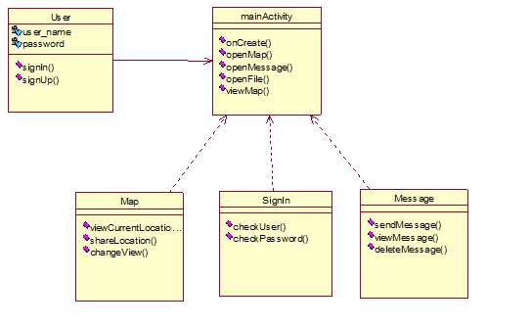

Fig. 3.2

**3.7.3 Sequence View**



**For message**

Fig. 3.3



**For group creation**

Fig. 3.4



**For location tracking**

Fig. 3.5

**3.7.4 Activity View**

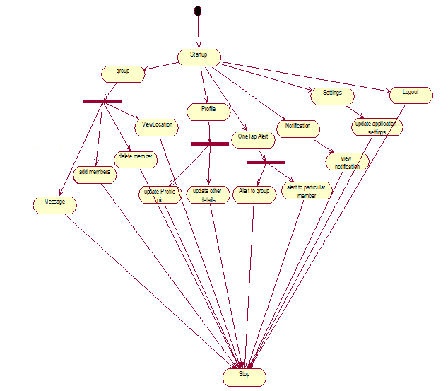

Fig. 3.6

**Chapter 4: Detailed Design**

***SPLASH SCREEN***: It is the starting activity (Page) of the Application, displaying the Project topic.



Fig. 4.1. Splash Screen

***SIGNUP PAGE***: The Splash Screen follows the User sign up/Registration page which allows user to create his/her account when the application is installed for the first time.

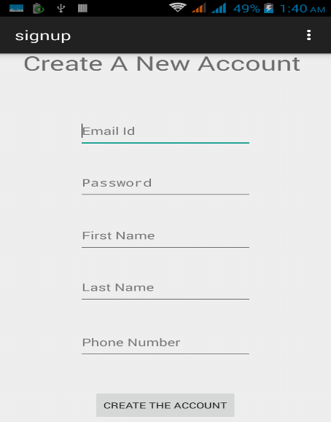

Fig. 4.2. SignUp screen

***LOGIN PAGE***: The user is required to login to use the application.

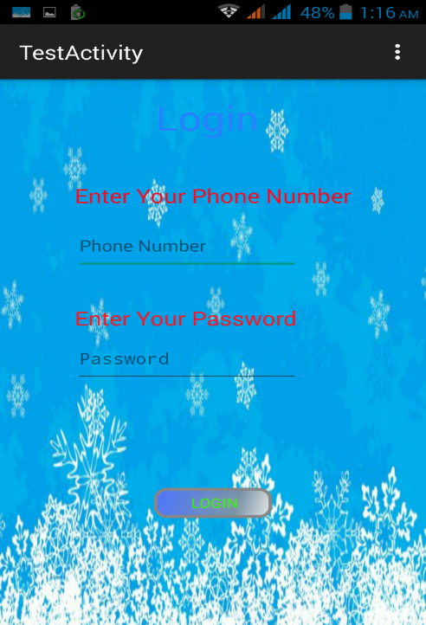

Fig. 4.3 Login screen

* **Maps**: The map activity is used to display the user’s current location in the map. It can also be used to search places and send the user’s current location to group members.

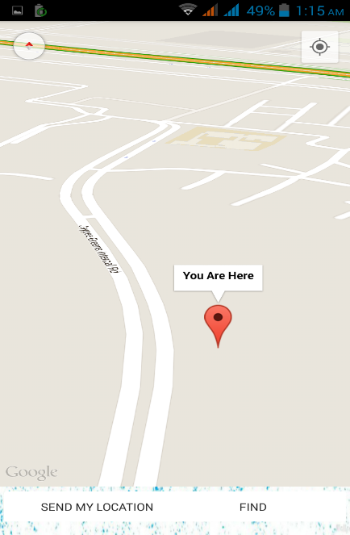 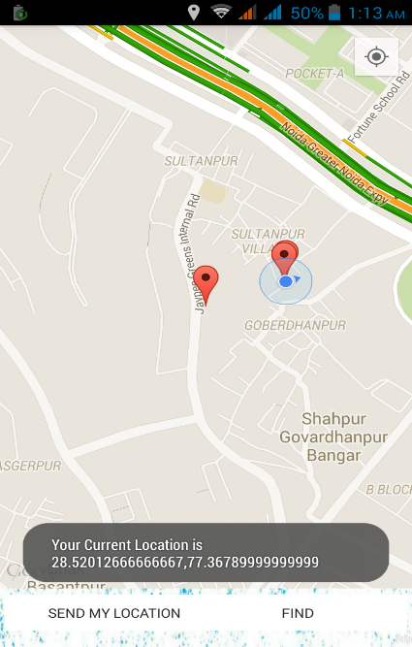 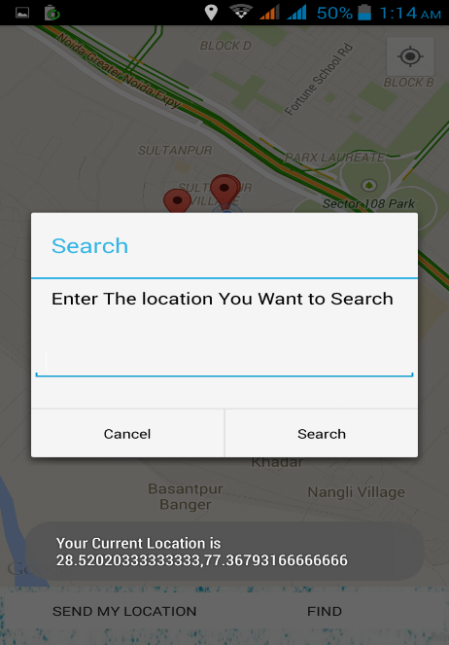

Fig.4.4 Map-1 Fig. 4.5 Map-3 Fig. 4.6 Map-3

* **Group activity**: It includes all the functions related to a group such as create group, add and delete group members and modifying details of a group member.

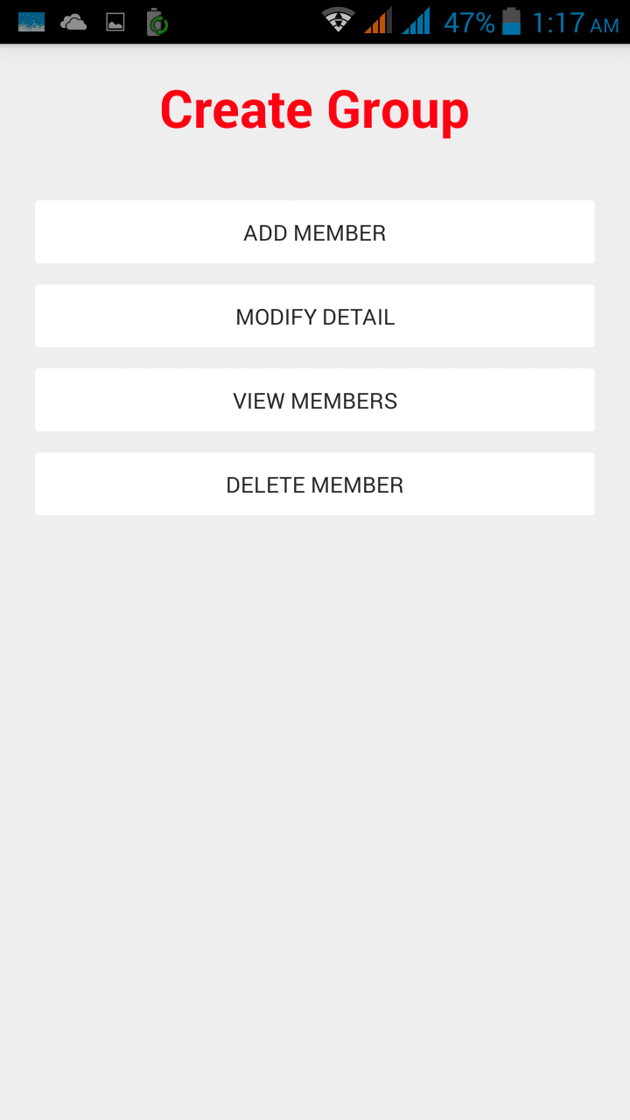 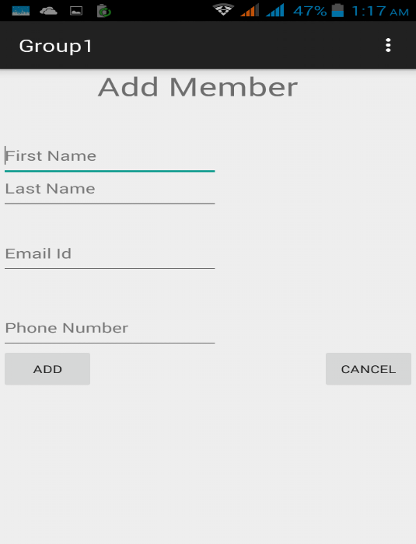

Fig. 4.7 Create Group Fig. 4.8 Group (Add Members)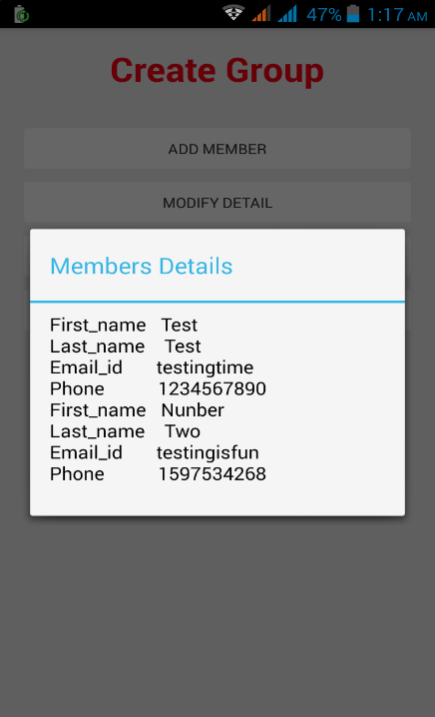 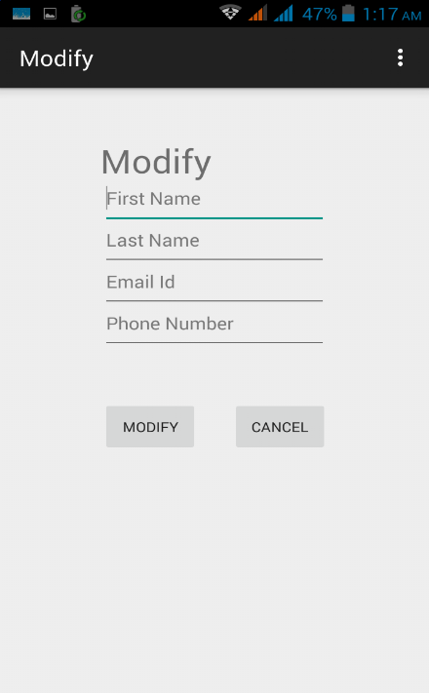 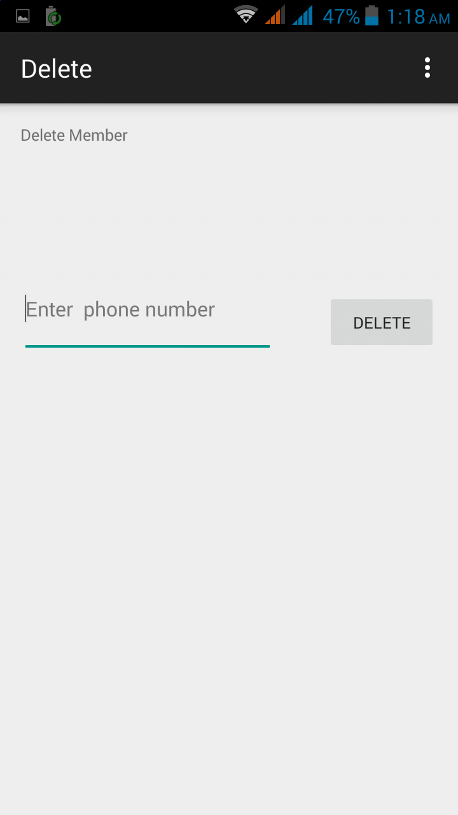

Fig. 4.9 View members Fig 4.10 Modify details Fig. 4.11 Delete Membe

**Chapter 5: Implementation**

This application is designed using java, GCM and SQLite in backend. It has been taken into consideration that a secured account of the user is created with the registration being done by the username and password being stored securely.

Splash

Splash

• App launched.  
• Splash Screen on for around 3 seconds.  
• Next the Menu appears.

Authenticate User

• If first time launched, the username & password entered registers the  
user.  
• If not first time, the username & password is used to authenticate locally.

Menu

• Preferences Setup already at default.

• Menu is extended to show Preferences and exit option too.

• “Map activity " is Clicked.

.

MapsMain

• MapView now displays the homepin at the current user location.  
• Map loaded. we stretch around to the required position on the map.  
• We touch that specific point on the map and address of that particular touched point on the map will be displayed.

Fig. 5.1

There are two possible actions in map activity. Firstly send their own location to group members and secondly search for any place in map.

• Click on “send my location” button. Location will be traced to others.

• Click on “search” button , the nearby places will be displayed.

• Back to parent activity.

Action in Map

Group Activity

• Click on group activity

• Members can be added, deleted

• Details can be modified and viewed

Fig. 5.2

**Chapter6: Testing Report**

|  |  |  |  |  |
| --- | --- | --- | --- | --- |
| **S. No.** | **Test Cases Description** | **Expected Output** | **Actual Output** | **Remark** |
| 1. | Splash Screen Activity | Display Splash Screen for 2 sec. | Splash Screen displayed for 2 sec. | Desired Output |
| 2. | Signup with information as directed | User registered | Successfully Registered | Desired Output |
| 3. | Signup with invalid information | Error Message displayed | Message Displayed | Desired Output |
| 4. | Signup with email id length less than 6 | Error Message  Displayed | Error Message Displayed | Desired Output |
| 5. | Signup with email id length greater than or equal to 6 | No error message | No error Message | Desired Output |
| 6. | Signup with Password length less than 7 | Error Message | Error Message | Desired Output |
| 7. | Login with any other Information than Databases | Error Message displayed | Message Displayed | Desired Output |
| 8. | Login again after visiting an activity with Valid Details | Successful Login | Error Message displayed | Undesired Output |
| 9. | Display User name on welcome Page | Name Displayed | Data from database fetched successfully | Desired Output |
| 10. | Button Click on Welcome page | Open respective activity | Successfully Opened | Desired Output |
| 11. | Check GPS is ON or OFF on MapsActivity Launch | Redirect to Turn on GPS Activity | Redirected | Desired Output |
| 12. | Click on My location Button | Display Current Location | Current Location Displayed | Desired Output |
| 13. | Click on Find Button | Display Entered Location | Location Displayed | Desired Output |
| 14. | Click on Send My location Button | Location Shared to all group through SMS | Location Shared | Desired Output |
| 15. | Click on send my location button | Location shared through internet | Location not shared | Undesired Output |
| 16. | Click on add member button | Add member page launched | Page launched Successfully | Desired Output |
| 17. | Enter valid info. to add member | Member added | Successfully added | Desired output |
| 18. | Enter invalid/ blank info. | Error message displayed | Message displayed | Desired Output |
| 19. | Enter valid info. to modify the detail of member | Detail modified | Successfully modified | Desired output |
| 20. | Enter invalid/ blank info. | Error message displayed | Message displayed | Desired Output |
| 21. | View Member details | Member details displayed | Details viewed Successfully | Desired Output |
| 22. | Click on delete member button | Delete member page launched | Page launched Successfully | Desired Output |

**Chapter 7: Conclusion and Future Work**

**Conclusion**

At the end, we find that, the application was really useful. The tracker unlike others is free of cost. The project taught us many innovative things to work on. The android platform by Google was the novice technology we learnt. We came to know all the installation needed to program on android like the SDK, Eclipse ADT–in that are very important from developers point of view. We learnt the android architecture. Also the research papers help us understand the location based services for the cell phones. We now know how to establish connection with Google server using private key. We also learnt how to use Google Map API interface, which again requires a private key. We also came to know how to interact with the storage of the android device. We learnt the concepts of Geo coding. The most important thing we learnt is how a project progresses through various stages of software development cycle through weekly updates versions and presentation.

**Possible Future Work**

• Tracker can be modified so as to implement Google Maps V3 APIs. They are more advanced & support 3D projections.

• The UI can definitely be improved by using Action Bars & other new end graphics introduced in latest versions of Android.

• Extending the application with some distance algorithms like dijkstra shortest path and including more parameters like speed, distance, it can be used for as a GPS.

• Photo tagging: LBS can be used to tag the photos clicked from camera and can be showed on the map on the location where they were clicked.

**Gantt chart**

|  |  |  |
| --- | --- | --- |
| **TASK** | **PERSON RESPONSIBLE** | **DATE** |
| Project discussion | All the group members | 01.02.2015 |
| Requirement Gathering | Nitesh , Shreyans | 04.02.2015 |
| Synopsis | All the group members | 18.03.2015 |
| Project planning | Nitesh, ketan | 21.03.2015 |
| Timeline of project | All the group members | 06.04.2015 |
| Designing | Ketan, Saurav | 25.04.2015 |
| Architecture | Shreyans, Saurav | 1.05.2015 |
| Coding | All the group members | 5.05.2015 |
| Testing | Nitesh,Shreyans | 6.05.2015 |

**REFERENCES**

[1] Travis Cornelius, New Boston Series 2015: Android Application Development tutorials Travis Cornelius, Available from:” http://www.mybringback.com/series/android-basics/” Accessed: April 23, 2015.

[2] Lars Vogel 2015: Android Development Tutorial Available From: https//:www.vogella.com/tutorials/ Accessed: April, 2015

[3] Google Code, Available from: http://code.google.com Accessed: April 29, 2015

[4] Android Dev Guide, Available from: http://developer.android.com/guide/index.html Accessed: April, 2015

[5] Research paper: Sekar, B.; Liu, J.B.,” Location Based Mobile Apps Development on Android Platform”, Industrial Electronics and Applications (ICIEA), 2014 IEEE 9th Conference, 2014, pp. 2148 – 2153.

[6] Research paper: Yazdi, N.T. ; Chan Huah Yong, ”A Potential Way for Efficient Information Sharing Based on Mobile Text Messaging” , Green and Ubiquitous Technology (GUT), 2012 International Conference, 2012 , pp. 172 - 175

[7] Research paper: Mantoro, Teddy; Feriadi; Agani, Natori; Ayu, Media A.; Jatikusumo, Dwiki, ” Location - Aware Mobile Crime Information Framework for Fast Tracking Response to Accidents and Crimes in Big Cities”, Advanced Computer Science Applications and Technologies (ACSAT), 2014 3rd International Conference, 2014, pp. 192 - 197